**Steps to running t-tests in IS**

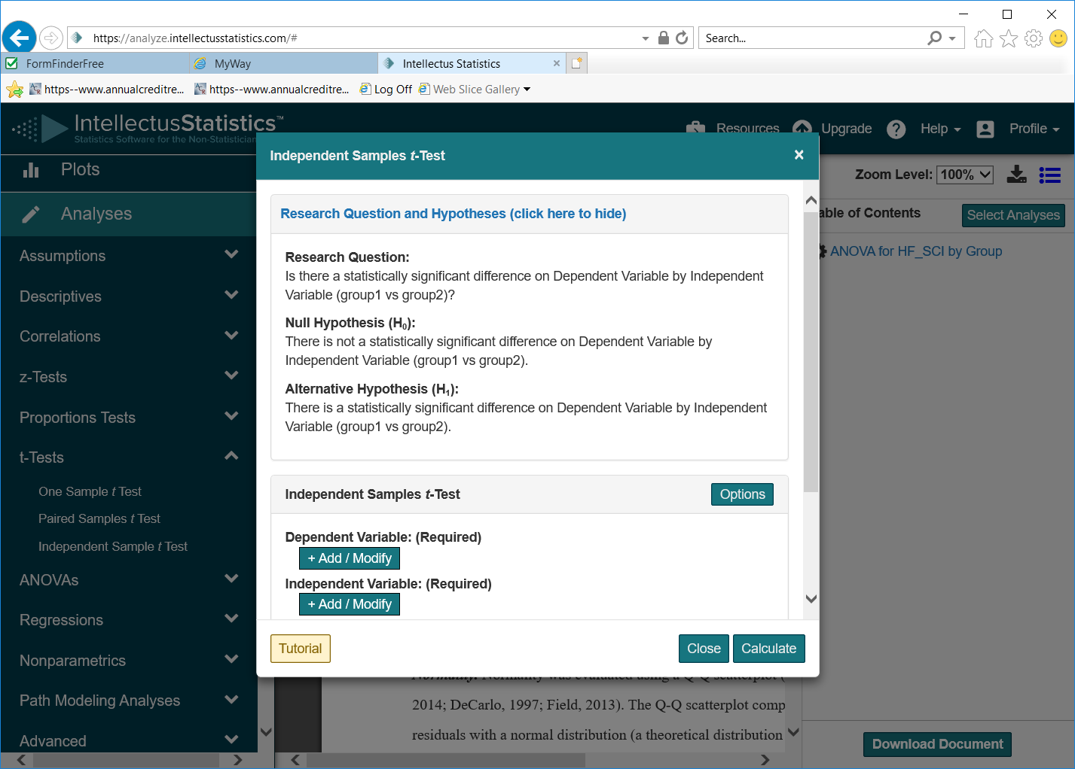

**Independent t test**

1. Select **Analysis**
2. Begin by selecting **t-tests**

Review the hypothesis- what type of t-test is needed?

11

1. Select **independent sample t-test**
2. Identify your independent and dependent variables

When ready click on the **+Add/Modify**

Use “down” arrow on the right hand side to see all possible variables

With the variable you want marked click on ‘add dependent variable’

Repeat the process for selecting your independent variable

Once both the IV and DV are entered view the research questions and hypothesis to check if OK

2&3& 31

Hit ‘**calculate’**

1. View the raw output view (choose button on top)

4

1. View the results.
2. View the document view to see example of write up

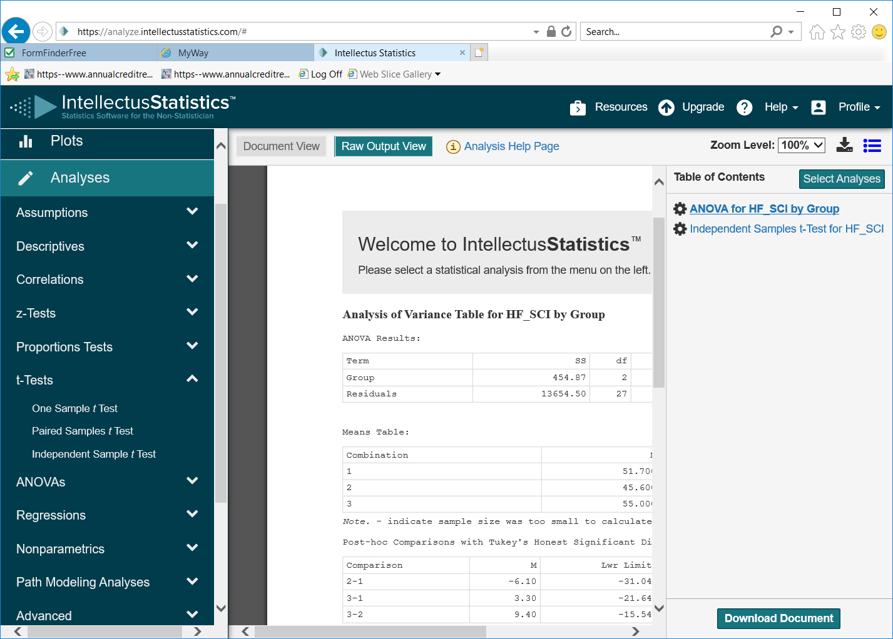

Additional help and information can be found by hitting the tutorial button

You can choose to enable or disable features using the options button.

E.g. enable Shapiro-Wilk test to examine normality assumption.

Set the number of tails and the alpha level

**Paired t test**

Similar process as above but instead of choosing independent t test on step 3 above choose paired sample test.